POSTER TITLE
Keywords:
Main subtheme | (select from list on Call for Papers)
Secondary subtheme | (select from list on Call for Papers
Author-Presenter
SURNAME | (e.g., FAMILY name, in UPPER CASE LETTERS)
Personal name | (lower case letters)
Title
Affiliation
Occupation
Address
Email
Telephone
Fax
Gender
Nationality
Country of Residence
Distance from Kitafuji | How far will this presenter need to travel to get to Kitafuji in June 2013?
Need for Visa | If you need a visa for short-term entry into Japan, do you already have one or will you need to apply for one?
Co-Author(s)
Address
Email
Affiliation
Funders/Sponsors of Research
Poster Title
Visual/Graphic Design | (maximum 300 words on what features of your topic are particularly suitable for graphic presentation, identifying the elements that you plan to present visually)
Poster Abstract: | (maximum 300 words on content and message of poster)
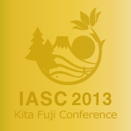 | The Commons: Commoners and the Changing Commons: Livelihoods, Environmental Security, and Shared Knowledge: Kitafuji Conference, Monday June 3 to Friday June 7, 2013  Mount Fuji, Japan

